Enrique Chagoya Artwork

Names
Institution Affiliation
Date

Introduction
The three paintings analyzed in this text are the work of Enrique Chagoya. He was born in Mexico to American and Indian parents. He was brought up by his mother who taught him the values of respecting the indigenous people and the culture of the Mexican people. These lessons influenced most of his works when grew up to be an artist (Gosse, 2010). He has been involved with very many painting and printed images among them these three paintings displayed at the San Jose Museum of Arts in San Jose California. Therefore, this essay explains how Enrique uses his painting address the issue of immigration which is a prevalent issue affecting the people of North and South America. He also told how the issue of politics has been in the midst of this issue and even, how poverty is putting people at in desperate conditions that forces to move away from their countries.
- Artwork Number One
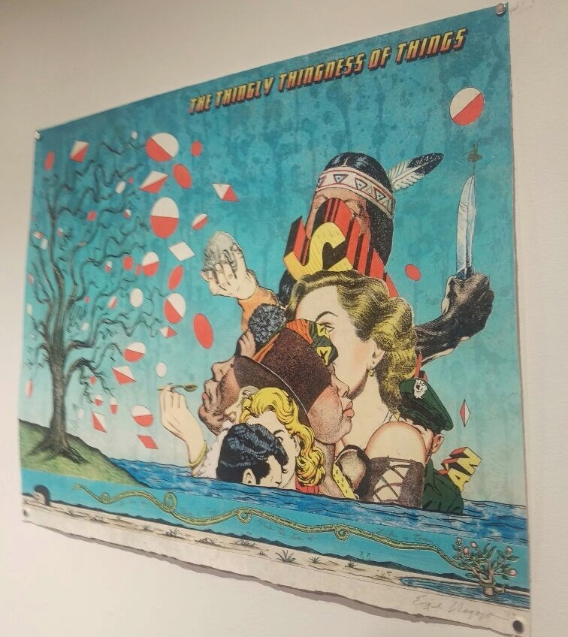
The title of this particular piece of art is “the thingly thingness of things.” In this piece of art, there are heads of people of different races and culture drawn. There are Americans, Africans, Indians and also Europeans. In this piece of art, he tries to show the diversity that is there in the world. There is diversity in culture and diversity in race and ethnic groups. This group of people can be said to representing the American community which mostly consists of the people depicted in the piece of art (Flores, 2015). Among this group of people is an Indian at the top who represents Enriques own heritage. Enrique was brought up with the lessons on how to always to respect his culture an idea conceived in most of his artworks. Also, there are white Americans represented by two women and two men. There are also African Americans in the picture something typical in the United States.
Most of his works have a lot of hidden meanings, and it is only through an in-depth analysis that a precise definition can be figured out. From this piece of art, placing the Indian at the uppermost position and being obstructed may symbolize the areas that the Indian hold in America. As much as they are the native of America they have been blocked from many opportunities. Also, the image only has one Indian compared to the four white people and three black people. This idea may symbolize the law population of the Indians in America who were once the native of the land. There is water surrounding all of the people represented in the painting which depicts the ocean that brought the people to America. The presence of a man dressed in police uniform may represent the authority of the government.

- Artwork Number Two
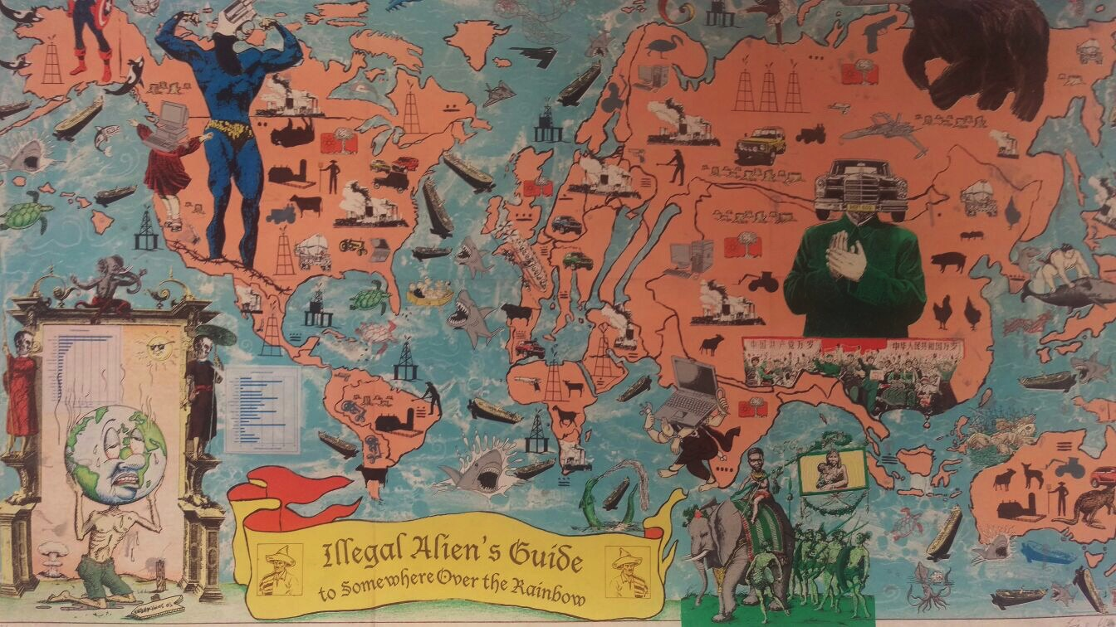
The title of this image is “The Pastoral of Arcadian State.” There is also a small subtitle that adds further descriptions of the image that says “ILLEGAL ALIEN’S GUIDE TO A GREATER AMERICA.” This image shows people dressed in old attires. In the foreground of the picture, there are various white people and a couple of black people surrounding a person who has his inner parts of the body exposed (Gosse, 2010). At the background of the image is another group of people standing in a circle, singing, and dancing. The landscape of place is hilly and covered with green grass and some threes.
From the title of this piece of art, we can deduce that it talks about the American people who lived in the rural areas during the time that they migrated to America. This incident occurred during the 16th century when the Europeans discovered America and called it “the new world.” The word “Arcadian” in this context describes the inhabitant of America. But there is controversy brought about in the subtitle through the use of the word “illegal aliens.” Enrique uses this word to describe the Europeans who came to America and took over the country under questionable circumstances.
From the image, there are various aspects brought about clearly about the early migration to America. One aspect is the issue of slavery which was very common at this particular time. There are two black people, a man seated down and a woman dressed as a house help attending to a white man. The person whose inner parts of the body are shown is standing in the midst of the seated men and seems to be narrating to the attentively listening audience. The narrator seems to be someone who has stayed in the newly discovered land and is giving advice on how to succeed in the land (Flores, 2015). The people dancing and singing in the background of this image represent the European culture that the Europeans brought with them when they came to America. The green grass and hilly landscape represent the “greener pasture” that the pastorals described in the image migrated to find.

- Artwork Number Three
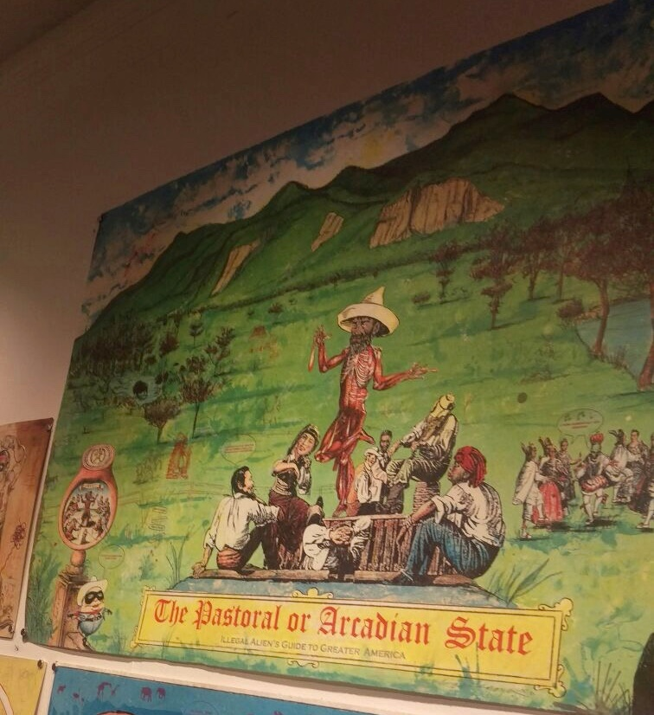
The title of this painting is “Illegal Aliens Guide to Somewhere over the Rainbow” this image show all the world and all the different culture that relate to a particular region. For example, in America, there is the image of Captain America a comic book and television character in Hollywood movie. This image represents the movie culture in America (Flores, 2015). In Russia, there is a bear which is an animal that is mostly used to portray Russia as a country. In the south Pacific, there is an image of a person riding a whale which is a legend told in New Zealand about their ancestors who rode at the back of whales.
There is also some aspect of controversy especially the image of a well-built body of a person whose head is a revolver. Enrique uses this picture to show the significant companies in the United States that are involved in weapons manufacture. There is a similar image in Asia of a person whose head is a car. The person is dressed like atypical Asian leader showing how Asian dominates in the car market. There is also an aspect of dictatorship the way the person is dressed just like the North Korea supreme leader (Gosse, 2010). Also, a similar image of an emaciated person whose head is the world is at the bottom left side of this piece of art. This image shows how the world is being frustrated by some of the changes including, global warming and population growth.
Conclusion
From the three pieces of artworks, the aspect of migration which is a crucial topic today has been brought up by Enrique. In the first image, he shows the diversity of the people in America who, except for the Indians are immigrant to the country. The same is also brought up in the second image when he defines the early European immigrants as illegal migrants. The third picture is all about embracing the diversity that is there in the world today. From the political standpoint of Enrique, it is evident that he is against the idea of restricting people from leaving in any part of the world. He is against the way most of the Mexican immigrants are treated in America for he believes that all those in America are immigrants. Therefore no one deserves to leave in America more than the other.

References
Flores, T. (2015). Latino Art and the Immigrant Artist: The Case of Sandra C. Fernández. Diálogo, 18(2), 167-172.
Gosse, J. (2010). Art on the Front Lines Contemporary Artists and Politics. Radical History Review, 2010(106), 198-214.

